**Supplementary Information for:**

**Multi-Objective Modeling framework for Environmental flow optimization**

**in a River-Reservoir system using Histogram Comparison Approach**

**for estimation of Hydrologic Alteration**

**Ruby Jose1and Srinivasan K2**

1Research Scholar, 2Professor (Retd.), Department of Civil Engineering, Indian Institute of Technology Madras, Chennai – 600036.

Corresponding author: Ruby Jose. J ([rubyphdwork@gmail.com](mailto:rubyphdwork@gmail.com))

Address: Department of Civil Engineering, IIT Madras, Chennai 600036, India.

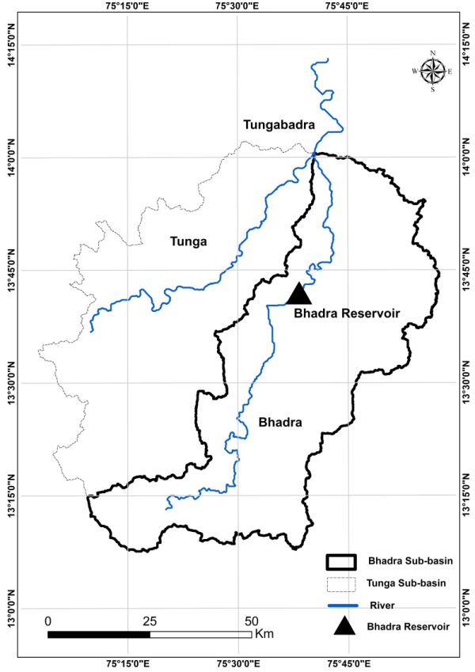

Fig. S1: Location map of the Bhadra river-reservoir system

(Delineated from SRTM DEM using ARC-GIS 10.2.2)

Table S1: Mean monthly inflows and monthly Irrigation target demands (Mm3).

|  |  |  |  |  |  |  |  |  |  |  |  |  |
| --- | --- | --- | --- | --- | --- | --- | --- | --- | --- | --- | --- | --- |
|  | *Jun* | *Jul* | *Aug* | *Sep* | *Oct* | *Nov* | *Dec* | *Jan* | *Feb* | *Mar* | *Apr* | *May* |
| *Mean Monthly*  *Inflow* | 243 | 771 | 820 | 323 | 209 | 100 | 48 | 27 | 15 | 10 | 11 | 18 |
| *Irrigation Target Demand* | 12 | 65 | 185 | 159 | 126 | 156 | 31 | 125 | 142 | 216 | 173 | 70 |

*All figures are in Mm3

Table S2: Selected PCs and indicators chosen from each PC of PCA based on the simulation results from HCA.

| **Indicator of HA** | **PCs with λ > 1** | | | | |
| --- | --- | --- | --- | --- | --- |
| **PC 27** | **PC 28** | **PC 29** | **PC 30** | **PC 31** |
| *Eigen values (λ)* | *1.10* | *1.46* | *2.16* | *9.14* | *13.35* |
| MM of June | 0.15 | 0.05 | 0.06 | 0.16 | 0.23 |
| MM of July | 0.29 | 0.01 | 0.11 | 0.10 | 0.21 |
| MM of August | 0.39 | 0.25 | 0.01 | 0.27 | 0.05 |
| MM of September | 0.01 | 0.00 | 0.03 | 0.01 | 0.26 |
| MM of October | 0.00 | 0.00 | 0.02 | 0.01 | 0.27 |
| MM of November | 0.13 | 0.10 | 0.02 | 0.07 | 0.25 |
| MM of December | 0.01 | **0.62** | 0.25 | 0.04 | 0.14 |
| MM of January | 0.06 | 0.10 | 0.06 | 0.03 | **0.27** |
| MM of February | 0.10 | 0.02 | 0.12 | 0.04 | 0.27 |
| MM of March | 0.01 | 0.27 | 0.18 | 0.27 | 0.08 |
| MM of April | 0.08 | 0.10 | 0.01 | 0.19 | 0.22 |
| MM of May | 0.21 | 0.13 | 0.09 | 0.25 | 0.15 |
| AMin of 1-day means | 0.00 | 0.08 | 0.14 | 0.13 | 0.23 |
| AMax of 1-day means | 0.06 | 0.23 | 0.32 | 0.27 | 0.02 |
| AMin of 3-day means | 0.09 | 0.10 | 0.03 | 0.22 | 0.17 |
| AMax of 3-day means | 0.16 | 0.15 | 0.34 | 0.19 | 0.14 |
| AMin of 7-day means | 0.13 | 0.03 | 0.04 | 0.15 | 0.24 |
| AMax of 7-day means | **0.45** | 0.08 | 0.06 | 0.29 | 0.00 |
| AMin 30-day means | 0.17 | 0.09 | 0.10 | **0.31** | 0.04 |
| AMax 30-day means | 0.20 | 0.24 | 0.31 | 0.11 | 0.18 |
| AMin 90-day means | 0.34 | 0.09 | 0.11 | 0.25 | 0.12 |
| AMax 90-day means | 0.05 | 0.35 | 0.20 | 0.20 | 0.15 |
| Base flow index | 0.03 | 0.09 | **0.38** | 0.07 | 0.21 |
| Date of minimum | 0.21 | 0.13 | 0.36 | 0.26 | 0.01 |
| Date of maximum | 0.00 | 0.00 | 0.00 | 0.00 | 0.00 |
| Low pulse count | 0.07 | 0.05 | 0.12 | 0.00 | 0.27 |
| Low pulse duration | 0.23 | 0.27 | 0.09 | 0.01 | 0.22 |
| High pulse count | 0.01 | 0.05 | 0.14 | 0.10 | 0.25 |
| High pulse duration | 0.05 | 0.16 | 0.35 | 0.24 | 0.07 |
| Rise rate | 0.34 | 0.10 | 0.15 | 0.30 | 0.01 |
| Fall rate | 0.00 | 0.00 | 0.00 | 0.00 | 0.00 |
| Number of reversals | 0.00 | 0.00 | 0.00 | 0.00 | 0.00 |

*MM – Monthly Median

*AMin-Annual Minima

*AMax – Annual Maxima

Table S3: Individual alterations of the PCA-selected IHA parameters of HCA pertaining to the Pareto-optimal solutions of the multi-objective run IMHA-HCA

| **Contribution rate of each PC** | | 49 | 34 | 8 | 5 | 4 |
| --- | --- | --- | --- | --- | --- | --- |
| **IrrMSI** | **HA-HCA** | **MM of January** | **AMin of**  **30-day means** | **Baseflow index** | **MM of December** | **Amax of**  **7-day means** |
| 0.13 | 40.95 | 41.89 | 31.58 | 41.75 | 5.26 | 62.16 |
| 0.13 | 38.92 | 39.69 | 31.58 | 34.42 | 5.26 | 61.56 |
| 0.16 | 37.73 | 35.75 | 28.95 | 34.42 | 5.26 | 61.56 |
| 0.17 | 37.65 | 34.69 | 28.95 | 34.42 | 8.42 | 61.56 |
| 0.39 | 37.38 | 39.25 | 28.95 | 35.57 | 5.26 | 57.57 |
| 0.49 | 37.21 | 39.25 | 28.95 | 34.98 | 2.63 | 57.57 |
| 0.54 | 36.17 | 35.11 | 28.95 | 34.98 | 5.26 | 56.73 |
| 0.56 | 35.93 | 35.11 | 28.95 | 34.98 | 5.26 | 55.97 |
| 0.72 | 35.86 | 35.11 | 28.95 | 33.83 | 12.37 | 55.34 |
| 0.76 | 34.92 | 35.11 | 28.95 | 28.45 | 12.37 | 55.34 |
| 0.77 | 34.80 | 35.11 | 28.95 | 27.74 | 12.37 | 55.34 |
| 0.79 | 34.20 | 35.11 | 28.95 | 23.68 | 12.37 | 55.34 |
| 0.80 | 34.06 | 35.11 | 28.95 | 22.64 | 12.37 | 55.34 |
| 0.82 | 33.88 | 35.11 | 28.95 | 22.64 | 5.03 | 55.97 |
| 0.84 | 33.68 | 35.11 | 28.95 | 22.64 | 5.03 | 55.34 |
| 0.90 | 33.53 | 35.11 | 28.95 | 22.64 | 5.03 | 54.88 |
| 1.20 | 33.49 | 33.12 | 28.95 | 22.64 | 5.26 | 55.97 |
| 1.22 | 33.28 | 33.12 | 28.95 | 22.64 | 5.26 | 55.34 |
| 1.24 | 33.12 | 33.12 | 28.95 | 22.64 | 5.03 | 54.88 |
| 2.50 | 32.67 | 31.58 | 38.17 | 24.48 | 8.20 | 47.07 |
| 2.53 | 31.74 | 27.53 | 38.17 | 24.48 | 2.63 | 47.07 |
| 2.55 | 31.62 | 28.57 | 36.84 | 23.68 | 2.63 | 47.51 |
| 2.56 | 31.49 | 28.57 | 36.84 | 23.68 | 2.63 | 47.07 |
| 2.58 | 31.30 | 27.53 | 36.84 | 42.96 | 2.63 | 47.07 |
| 2.71 | 31.25 | 28.57 | 36.84 | 21.05 | 2.63 | 47.51 |
| 2.72 | 31.06 | 27.53 | 36.84 | 21.05 | 2.63 | 47.51 |
| 2.78 | 30.92 | 27.53 | 36.84 | 21.05 | 2.63 | 47.07 |
| 2.99 | 30.72 | 28.57 | 36.84 | 21.05 | 5.26 | 45.53 |
| 3.01 | 30.64 | 27.53 | 36.84 | 21.05 | 7.89 | 45.53 |
| 3.01 | 30.53 | 27.53 | 36.84 | 21.05 | 5.26 | 45.53 |
| 3.09 | 30.43 | 27.53 | 38.17 | 23.42 | 5.26 | 42.88 |
| 3.12 | 29.70 | 27.53 | 38.17 | 23.42 | 5.26 | 40.22 |
| 3.14 | 29.54 | 28.57 | 38.17 | 21.05 | 5.26 | 40.22 |
| 3.14 | 29.34 | 27.53 | 38.17 | 21.05 | 5.26 | 40.22 |
| 3.28 | 28.95 | 28.57 | 38.17 | 21.05 | 5.26 | 38.04 |
| 3.68 | 28.81 | 27.86 | 38.17 | 21.05 | 5.26 | 38.04 |
| 3.88 | 28.61 | 28.57 | 36.84 | 21.05 | 5.26 | 38.04 |
| 4.16 | 28.59 | 27.86 | 36.84 | 21.05 | 5.26 | 38.51 |
| 4.20 | 28.46 | 27.86 | 36.84 | 21.05 | 5.26 | 38.04 |
| 4.30 | 28.43 | 24.80 | 36.84 | 21.05 | 11.93 | 38.51 |
| 4.30 | 28.02 | 24.80 | 36.84 | 21.05 | 5.26 | 38.51 |
| 4.35 | 27.89 | 24.80 | 36.84 | 21.05 | 5.26 | 38.04 |

*All figures are in %; AMax- annual maxima; AMin-annual minima; MM- monthly median

Table S4: Performance of the six selected P-O solutions of IMHA-HCA in terms of Irrigation MSI and average monthly Irrigation deficits.

|  |  |  |  |  |  |  |  |  |  |  |  |  |  |  |
| --- | --- | --- | --- | --- | --- | --- | --- | --- | --- | --- | --- | --- | --- | --- |
| **Solution** | **HA-HCA** | **Irrigation MSI** | **Average monthly Irrigation deficits** | | | | | | | | | | | |
| J | J | A | S | O | N | D | J | F | M | A | M |
| **HCA - 1** | 33.28 | 1.22 | 8 | 9 | 7 | 9 | 10 | 3 | 3 | 3 | 9 | 9 | 12 | 12 |
| **HCA - 2** | 32.67 | 2.50 | 12 | 12 | 5 | 4 | 4 | 3 | 4 | 3 | 10 | 12 | 15 | 19 |
| **HCA - 3** | 31.62 | 2.55 | 12 | 13 | 5 | 6 | 5 | 3 | 4 | 3 | 11 | 12 | 17 | 17 |
| **HCA - 4** | 30.72 | 2.99 | 13 | 13 | 4 | 7 | 8 | 4 | 4 | 4 | 12 | 13 | 18 | 17 |
| **HCA - 5** | 29.70 | 3.12 | 12 | 12 | 4 | 11 | 10 | 4 | 5 | 4 | 12 | 14 | 18 | 20 |
| **HCA - 6** | 28.95 | 3.28 | 14 | 14 | 5 | 12 | 10 | 5 | 6 | 4 | 12 | 15 | 18 | 20 |

*All figures are in %

Table S5: Distribution of deficits in various storage zones during the simulation period for two selected solutions from the P-O front of IMHA-HCA.

|  |  |  |  |  |  |  |  |  |  |  |  |
| --- | --- | --- | --- | --- | --- | --- | --- | --- | --- | --- | --- |
|  | | **E-flows** | | | | | **Irrigation** | | | | |
| **IMHA-HCA-33.28 (HCA - 1)** | | | | | | | | | |
| Initial storage zone | Number of periods  (456) | Number of zero deficit periods | Distribution of deficit periods | | | | Number of zero deficit periods | Distribution of deficit periods | | | | |
| Mild | Moderate | Severe | Very severe | Mild | Moderate | Severe | Very severe | |
| 4 | 9 | 9 | 0 | 0 | 0 | 0 | 9 | 0 | 0 | 0 | 0 | |
| 3 | 74 | 74 | 0 | 0 | 0 | 0 | 74 | 0 | 0 | 0 | 0 | |
| 2 to 3 | 313 | 313 | 0 | 0 | 0 | 0 | 45 | 268 | 0 | 0 | 0 | |
| 2 | 0 | 0 | 0 | 0 | 0 | 0 | 0 | 0 | 0 | 0 | 0 | |
| 1 to 2 | 28 | 3 | 3 | 15 | 2 | 5 | 3 | 25 | 0 | 0 | 0 | |
| 1 | 32 | 0 | 2 | 0 | 1 | 29 | 0 | 28 | 2 | 1 | 1 | |
|  | | **IMHA-HCA-32.67 (HCA - 2)** | | | | | | | | | |
| Initial storage zone | Number of periods (456) | Number of zero deficit periods | Distribution of deficit periods | | | | Number of zero deficit periods | Distribution of deficit periods | | | | |
| Mild | Moderate | Severe | Very severe | Mild | Moderate | Severe | Very severe | |
| 4 | 0 | 0 | 0 | 0 | 0 | 0 | 0 | 0 | 0 | 0 | 0 | |
| 3 | 126 | 126 | 0 | 0 | 0 | 0 | 126 | 0 | 0 | 0 | 0 | |
| 2 to 3 | 263 | 263 | 0 | 0 | 0 | 0 | 30 | 233 | 0 | 0 | 0 | |
| 2 | 2 | 2 | 0 | 0 | 0 | 0 | 0 | 2 | 0 | 0 | 0 | |
| 1 to 2 | 12 | 1 | 2 | 9 | 0 | 0 | 1 | 11 | 0 | 0 | 0 | |
| 1 | 53 | 1 | 0 | 0 | 0 | 52 | 1 | 0 | 43 | 2 | 7 | |

*very severe (≥70%); severe (50%-70%); moderate (20%-50%) and mild (>0 and <20%)

Table S6: Selected PCs and indicators chosen from each PC of PCA based on the simulation results from RVA.

| **Indicator of HA** | **PCs with λ > 1** | | | | | |
| --- | --- | --- | --- | --- | --- | --- |
| **PC 27** | **PC 28** | **PC 29** | **PC 30** | **PC 31** | **PC 32** |
| *Eigen values (λ)* | *1.50* | *1.68* | *3.31* | *3.64* | *7.72* | *11.81* |
| MM of June | 0.18 | 0.19 | 0.04 | 0.00 | 0.17 | 0.22 |
| MM of July | 0.03 | 0.03 | 0.13 | 0.41 | 0.19 | 0.00 |
| MM of August | 0.02 | 0.08 | 0.25 | 0.10 | 0.14 | 0.22 |
| MM of September | 0.34 | 0.12 | 0.19 | 0.06 | 0.10 | 0.20 |
| MM of October | 0.05 | 0.37 | 0.08 | 0.21 | 0.15 | 0.13 |
| MM of November | 0.02 | 0.11 | 0.09 | 0.14 | 0.17 | 0.22 |
| MM of December | 0.16 | 0.00 | 0.04 | 0.28 | 0.17 | 0.15 |
| MM of January | 0.13 | 0.04 | 0.15 | 0.09 | 0.14 | 0.21 |
| MM of February | 0.01 | 0.03 | 0.06 | 0.16 | 0.22 | 0.20 |
| MM of March | 0.03 | 0.11 | 0.07 | 0.12 | 0.23 | 0.19 |
| MM of April | 0.18 | 0.21 | 0.26 | 0.05 | 0.03 | 0.23 |
| MM of May | 0.44 | 0.31 | 0.22 | 0.13 | 0.05 | 0.11 |
| AMin of 1-day means | 0.02 | 0.02 | 0.12 | 0.16 | 0.24 | 0.16 |
| AMax of 1-day means | 0.08 | 0.15 | 0.32 | 0.31 | 0.04 | 0.14 |
| AMin of 3-day means | 0.34 | 0.11 | 0.10 | 0.01 | 0.28 | 0.11 |
| AMax of 3-day means | 0.10 | 0.03 | 0.31 | 0.10 | 0.13 | 0.20 |
| AMin of 7-day means | 0.13 | 0.06 | 0.02 | 0.04 | 0.26 | 0.19 |
| AMax of 7-day means | 0.11 | 0.01 | 0.34 | 0.08 | 0.05 | 0.21 |
| AMin 30-day means | 0.00 | 0.03 | 0.01 | 0.22 | 0.21 | 0.19 |
| AMax 30-day means | 0.12 | 0.09 | 0.27 | 0.08 | 0.06 | 0.23 |
| AMin 90-day means | 0.04 | 0.08 | 0.26 | 0.10 | 0.19 | 0.19 |
| AMax 90-day means | 0.11 | 0.16 | 0.05 | 0.09 | 0.32 | 0.08 |
| Base flow index | 0.12 | 0.03 | 0.05 | 0.29 | 0.20 | 0.16 |
| Date of minimum | 0.32 | 0.27 | 0.07 | 0.15 | 0.26 | 0.09 |
| Date of maximum | 0.04 | 0.06 | 0.23 | 0.38 | 0.16 | 0.05 |
| Low pulse count | 0.10 | 0.09 | 0.24 | 0.06 | 0.03 | 0.25 |
| Low pulse duration | 0.17 | 0.13 | 0.04 | 0.19 | 0.12 | 0.23 |
| High pulse count | 0.35 | 0.03 | 0.15 | 0.22 | 0.22 | 0.13 |
| High pulse duration | 0.07 | 0.05 | 0.18 | 0.20 | 0.06 | 0.20 |
| Rise rate | 0.15 | 0.62 | 0.10 | 0.13 | 0.04 | 0.12 |
| Fall rate | 0.19 | 0.08 | 0.20 | 0.02 | 0.26 | 0.10 |
| Number of reversals | 0.23 | 0.26 | 0.10 | 0.07 | 0.15 | 0.21 |

*MM – Monthly Median

*AMin-Annual Minima

*AMax – Annual Maxima

Table S7: Individual alterations of the PCA-selected IHA parameters of RVA pertaining to the Pareto-optimal solutions of the multi-objective run IMHA-RVA

| **Contribution rate of each PC** | | 40 | 26 | 12 | 11 | 6 | 5 |
| --- | --- | --- | --- | --- | --- | --- | --- |
| **Irr**  **MSI** | **HA-RVA** | **Low Pulse count** | **AMax of 90-day means** | **MM of July** | **AMax of 7-day means** | **Rise Rate** | **MM of May** |
| 0.16 | 52.00 | 0.00 | 78.57 | 50.00 | 85.71 | 0.00 | 14.29 |
| 0.19 | 51.67 | 0.00 | 78.57 | 50.00 | 85.71 | 0.00 | 0.00 |
| 0.20 | 50.42 | 14.29 | 78.57 | 50.00 | 78.57 | 0.00 | 14.29 |
| 0.20 | 50.08 | 0.00 | 78.57 | 50.00 | 78.57 | 0.00 | 14.29 |
| 0.23 | 47.92 | 0.00 | 71.43 | 50.00 | 78.57 | 0.00 | 0.00 |
| 0.27 | 47.11 | 14.29 | 71.43 | 42.86 | 78.57 | 0.00 | 0.00 |
| 0.28 | 46.84 | 7.14 | 71.43 | 42.86 | 78.57 | 0.00 | 0.00 |
| 0.30 | 44.80 | 0.00 | 71.43 | 42.86 | 71.43 | 0.00 | 0.00 |
| 0.54 | 43.15 | 7.14 | 64.29 | 42.86 | 71.43 | 0.00 | 7.14 |
| 0.56 | 43.06 | 0.00 | 64.29 | 42.86 | 71.43 | 0.00 | 7.14 |
| 0.63 | 42.96 | 0.00 | 64.29 | 42.86 | 71.43 | 0.00 | 0.00 |
| 1.25 | 42.66 | 7.14 | 71.43 | 50.00 | 57.14 | 0.00 | 0.00 |
| 1.25 | 42.56 | 0.00 | 71.43 | 50.00 | 57.14 | 0.00 | 0.00 |
| 1.28 | 40.72 | 21.43 | 71.43 | 50.00 | 42.86 | 7.14 | 0.00 |
| 1.29 | 40.62 | 21.43 | 71.43 | 50.00 | 42.86 | 0.00 | 0.00 |
| 1.30 | 39.77 | 0.00 | 71.43 | 50.00 | 42.86 | 7.14 | 0.00 |
| 1.30 | 39.66 | 0.00 | 71.43 | 50.00 | 42.86 | 0.00 | 0.00 |
| 1.51 | 38.13 | 14.29 | 64.29 | 50.00 | 42.86 | 7.14 | 0.00 |
| 1.53 | 37.68 | 0.00 | 64.29 | 50.00 | 42.86 | 7.14 | 0.00 |
| 1.54 | 37.57 | 0.00 | 64.29 | 50.00 | 42.86 | 0.00 | 0.00 |
| 1.62 | 36.65 | 14.29 | 64.29 | 42.86 | 42.86 | 7.14 | 0.00 |
| 1.64 | 36.19 | 0.00 | 64.29 | 42.86 | 42.86 | 7.14 | 0.00 |
| 1.65 | 36.07 | 0.00 | 64.29 | 42.86 | 42.86 | 0.00 | 0.00 |
| 1.95 | 34.38 | 21.43 | 64.29 | 14.29 | 42.86 | 0.00 | 21.43 |
| 1.95 | 33.12 | 14.29 | 64.29 | 14.29 | 42.86 | 0.00 | 14.29 |
| 1.96 | 32.73 | 7.14 | 64.29 | 14.29 | 42.86 | 0.00 | 14.29 |
| 2.00 | 32.21 | 7.14 | 64.29 | 14.29 | 42.86 | 0.00 | 0.00 |
| 2.03 | 32.08 | 0.00 | 64.29 | 14.29 | 42.86 | 0.00 | 0.00 |
| 2.15 | 31.68 | 0.00 | 64.29 | 7.14 | 42.86 | 0.00 | 0.00 |
| 2.40 | 31.00 | 7.14 | 64.29 | 14.29 | 35.71 | 7.14 | 7.14 |
| 2.41 | 30.72 | 7.14 | 64.29 | 14.29 | 35.71 | 0.00 | 0.00 |
| 2.46 | 30.58 | 0.00 | 64.29 | 14.29 | 35.71 | 0.00 | 0.00 |
| 2.84 | 30.44 | 7.14 | 64.29 | 7.14 | 35.71 | 0.00 | 7.14 |
| 2.85 | 30.30 | 7.14 | 64.29 | 7.14 | 35.71 | 0.00 | 0.00 |
| 3.20 | 30.16 | 0.00 | 64.29 | 7.14 | 35.71 | 0.00 | 0.00 |
| 3.38 | 30.02 | 14.29 | 64.29 | 7.14 | 28.57 | 14.29 | 0.00 |
| 3.40 | 29.16 | 7.14 | 64.29 | 7.14 | 28.57 | 7.14 | 0.00 |
| 3.41 | 29.01 | 0.00 | 64.29 | 7.14 | 28.57 | 7.14 | 0.00 |
| 3.42 | 28.87 | 0.00 | 64.29 | 7.14 | 28.57 | 0.00 | 0.00 |
| 5.93 | 28.57 | 7.14 | 57.14 | 7.14 | 35.71 | 7.14 | 14.29 |
| 5.94 | 28.42 | 7.14 | 57.14 | 7.14 | 35.71 | 0.00 | 14.29 |
| 5.96 | 28.27 | 0.00 | 57.14 | 7.14 | 35.71 | 0.00 | 14.29 |
| 6.21 | 28.12 | 0.00 | 57.14 | 0.00 | 35.71 | 0.00 | 14.29 |
| 6.26 | 27.97 | 7.14 | 57.14 | 7.14 | 35.71 | 0.00 | 7.14 |
| 6.27 | 27.82 | 0.00 | 57.14 | 7.14 | 35.71 | 0.00 | 7.14 |
| 6.29 | 27.66 | 0.00 | 57.14 | 0.00 | 35.71 | 0.00 | 7.14 |
| 6.39 | 27.36 | 7.14 | 50.00 | 0.00 | 35.71 | 14.29 | 21.43 |
| 6.42 | 26.88 | 7.14 | 50.00 | 0.00 | 35.71 | 7.14 | 21.43 |
| 6.44 | 26.73 | 0.00 | 50.00 | 0.00 | 35.71 | 7.14 | 21.43 |
| 6.46 | 26.57 | 7.14 | 50.00 | 0.00 | 35.71 | 14.29 | 14.29 |
| 6.47 | 26.08 | 7.14 | 50.00 | 0.00 | 35.71 | 7.14 | 14.29 |
| 6.49 | 25.92 | 0.00 | 50.00 | 0.00 | 35.71 | 7.14 | 14.29 |
| 6.51 | 25.75 | 0.00 | 50.00 | 0.00 | 35.71 | 0.00 | 14.29 |
| 6.86 | 25.59 | 0.00 | 50.00 | 7.14 | 35.71 | 7.14 | 7.14 |
| 6.87 | 25.25 | 0.00 | 50.00 | 0.00 | 35.71 | 0.00 | 7.14 |
| 6.88 | 23.87 | 0.00 | 42.86 | 7.14 | 35.71 | 14.29 | 7.14 |
| 6.90 | 23.33 | 0.00 | 42.86 | 7.14 | 35.71 | 7.14 | 7.14 |
| 6.91 | 22.02 | 7.14 | 35.71 | 7.14 | 35.71 | 14.29 | 7.14 |
| 6.92 | 21.82 | 0.00 | 35.71 | 7.14 | 35.71 | 14.29 | 7.14 |
| 6.92 | 21.23 | 0.00 | 35.71 | 7.14 | 35.71 | 7.14 | 7.14 |
| 6.94 | 21.03 | 0.00 | 35.71 | 0.00 | 35.71 | 7.14 | 7.14 |
| 6.99 | 20.82 | 14.29 | 35.71 | 7.14 | 28.57 | 14.29 | 7.14 |
| 7.01 | 19.56 | 7.14 | 35.71 | 7.14 | 28.57 | 7.14 | 7.14 |
| 7.02 | 19.34 | 0.00 | 35.71 | 7.14 | 28.57 | 7.14 | 7.14 |
| 7.04 | 19.12 | 0.00 | 35.71 | 7.14 | 28.57 | 7.14 | 0.00 |
| 7.06 | 18.90 | 0.00 | 35.71 | 7.14 | 28.57 | 0.00 | 0.00 |
| 7.10 | 18.67 | 0.00 | 35.71 | 0.00 | 28.57 | 0.00 | 0.00 |
| 7.86 | 17.98 | 7.14 | 35.71 | 7.14 | 21.43 | 7.14 | 7.14 |
| 7.86 | 17.74 | 0.00 | 35.71 | 7.14 | 21.43 | 7.14 | 7.14 |
| 7.89 | 17.50 | 0.00 | 35.71 | 7.14 | 21.43 | 0.00 | 7.14 |
| 7.90 | 17.25 | 0.00 | 35.71 | 7.14 | 21.43 | 0.00 | 0.00 |
| 7.96 | 17.00 | 0.00 | 35.71 | 0.00 | 21.43 | 0.00 | 0.00 |
| 8.20 | 15.15 | 7.14 | 28.57 | 0.00 | 21.43 | 7.14 | 0.00 |
| 8.20 | 14.87 | 0.00 | 28.57 | 0.00 | 21.43 | 7.14 | 0.00 |
| 9.30 | 13.68 | 7.14 | 28.57 | 0.00 | 14.29 | 0.00 | 7.14 |
| 9.35 | 13.36 | 0.00 | 28.57 | 0.00 | 14.29 | 0.00 | 7.14 |
| 9.57 | 13.04 | 0.00 | 28.57 | 0.00 | 14.29 | 0.00 | 0.00 |
| 9.94 | 12.71 | 0.00 | 21.43 | 0.00 | 21.43 | 0.00 | 7.14 |
| 9.95 | 12.37 | 0.00 | 21.43 | 0.00 | 21.43 | 0.00 | 0.00 |
| 9.97 | 11.29 | 0.00 | 21.43 | 7.14 | 14.29 | 0.00 | 7.14 |
| 10.00 | 10.91 | 0.00 | 21.43 | 7.14 | 14.29 | 0.00 | 0.00 |
| 10.07 | 10.51 | 0.00 | 21.43 | 0.00 | 14.29 | 0.00 | 0.00 |
| 10.21 | 9.22 | 7.14 | 14.29 | 7.14 | 14.29 | 0.00 | 0.00 |
| 10.23 | 8.75 | 0.00 | 14.29 | 7.14 | 14.29 | 0.00 | 0.00 |
| 10.30 | 8.25 | 0.00 | 14.29 | 0.00 | 14.29 | 0.00 | 0.00 |
| 15.31 | 7.72 | 0.00 | 7.14 | 7.14 | 14.29 | 7.14 | 0.00 |
| 15.34 | 7.14 | 0.00 | 7.14 | 7.14 | 14.29 | 0.00 | 0.00 |
| 16.92 | 6.52 | 7.14 | 7.14 | 7.14 | 7.14 | 0.00 | 7.14 |
| 16.93 | 5.83 | 7.14 | 0.00 | 7.14 | 7.14 | 0.00 | 7.14 |

*All figures are in %; AMax- annual maxima; MM- monthly median

Table S8: Performance of the four selected P-O solutions of IMHA-RVA in terms of Irrigation MSI and average monthly Irrigation deficits.

|  |  |  |  |  |  |  |  |  |  |  |  |  |  |  |
| --- | --- | --- | --- | --- | --- | --- | --- | --- | --- | --- | --- | --- | --- | --- |
| **Solution** | **HA- RVA** | **Irrigation MSI** | **Average monthly Irrigation deficits** | | | | | | | | | | | |
| J | J | A | S | O | N | D | J | F | M | A | M |
| **RVA-1** | 33.12 | 1.95 | 7 | 12 | 5 | 9 | 12 | 9 | 8 | 10 | 5 | 11 | 12 | 13 |
| **RVA-2** | 32.1 | 2.03 | 8 | 12 | 6 | 10 | 13 | 9 | 8 | 10 | 5 | 11 | 15 | 12 |
| **RVA-3** | 31 | 2.40 | 11 | 15 | 8 | 13 | 12 | 12 | 11 | 12 | 6 | 10 | 11 | 10 |
| **RVA-4** | 30.02 | 3.38 | 17 | 21 | 14 | 16 | 13 | 13 | 12 | 11 | 6 | 14 | 15 | 11 |

*All figures are in %

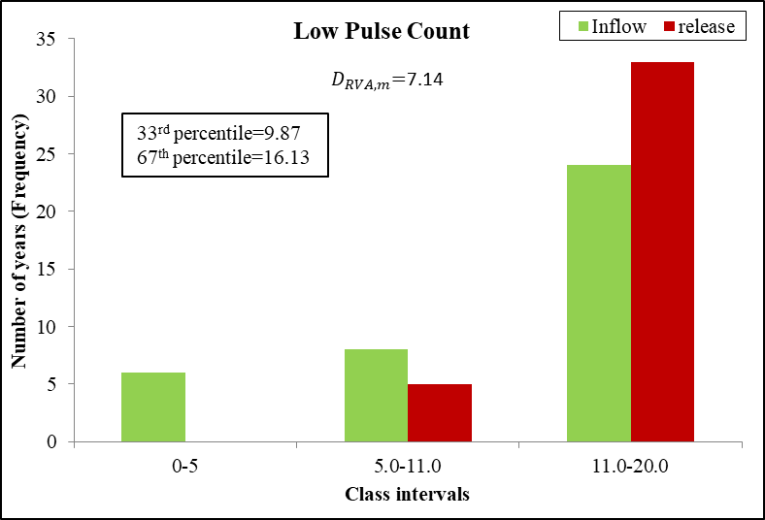 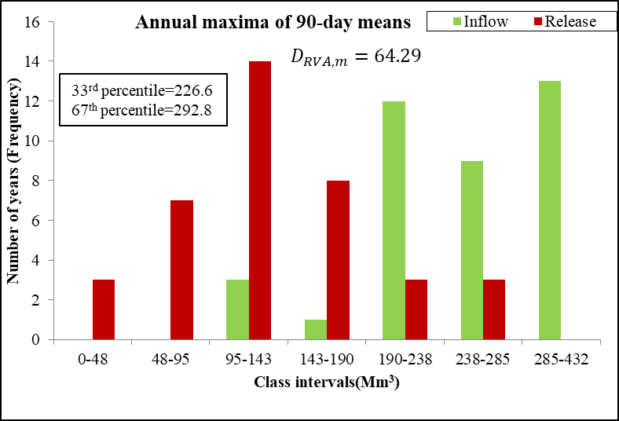 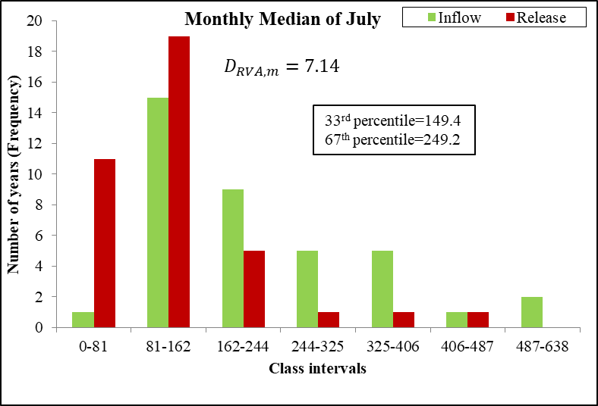 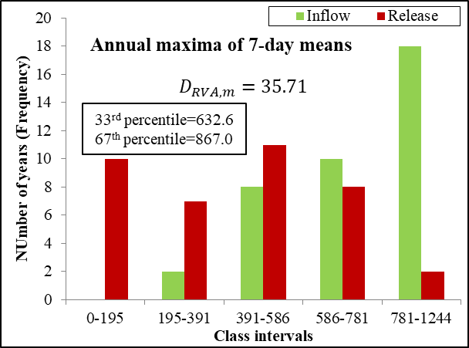

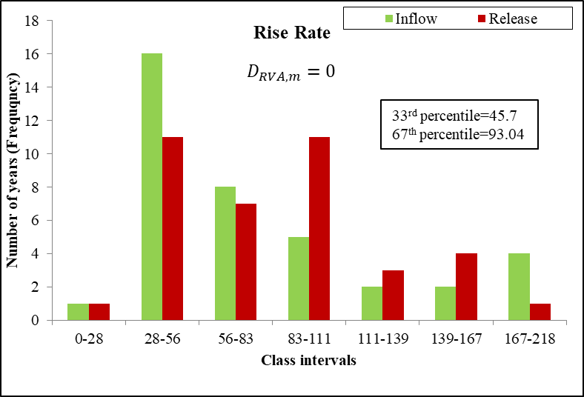 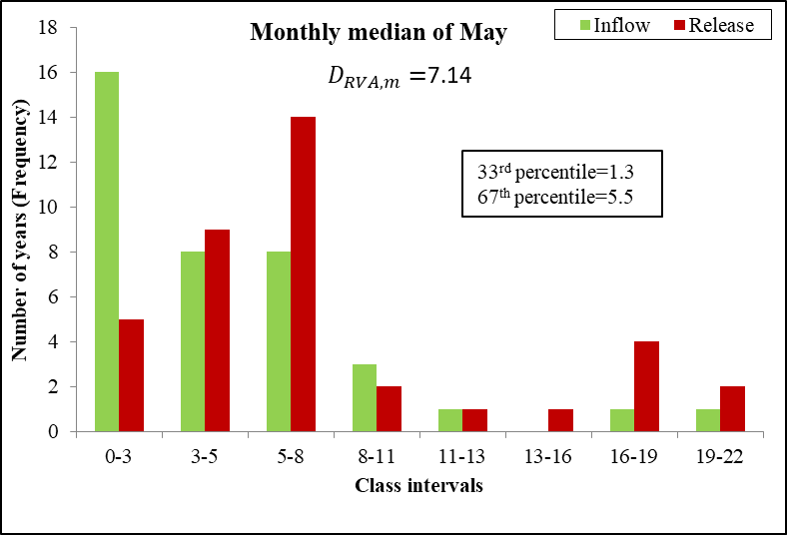

Fig. S2: Distribution of PCA selected release statistics of IMHA-RVA-30.44 across the various class intervals covering the entire range of inflow statistics.

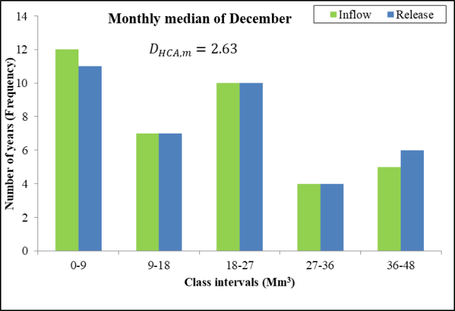 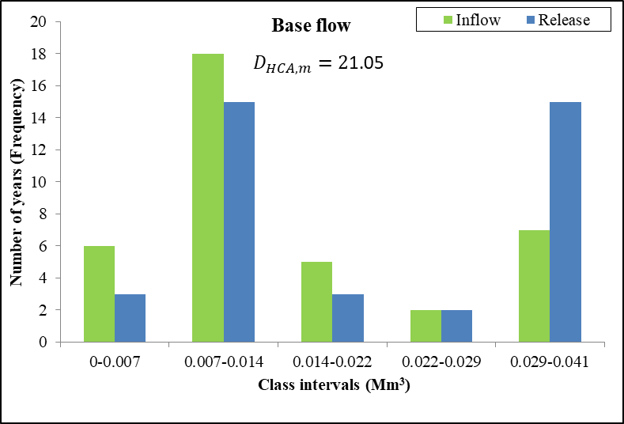

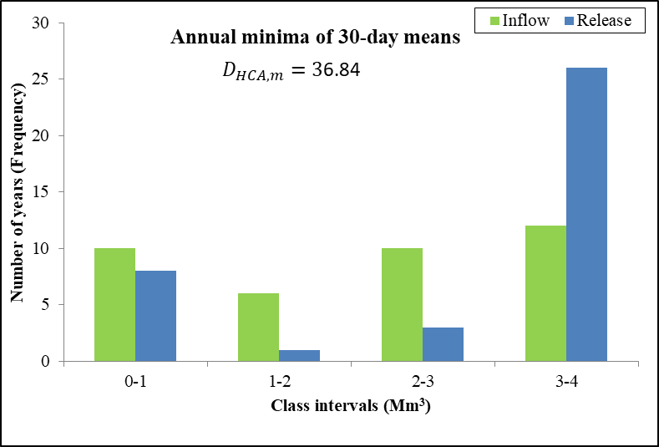 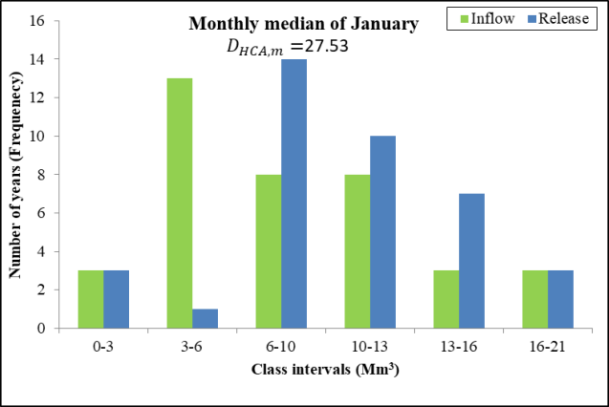

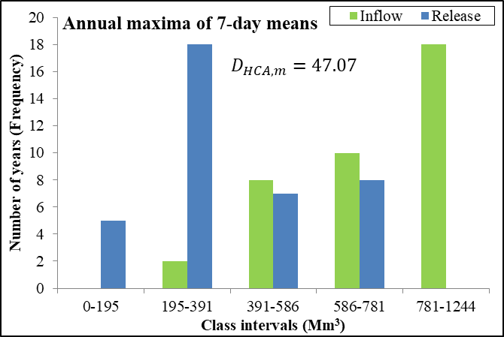

Fig. S3: Distribution of PCA selected release statistics of IMHA-HCA-30.92 across the various class intervals covering the entire range of inflow statistics.

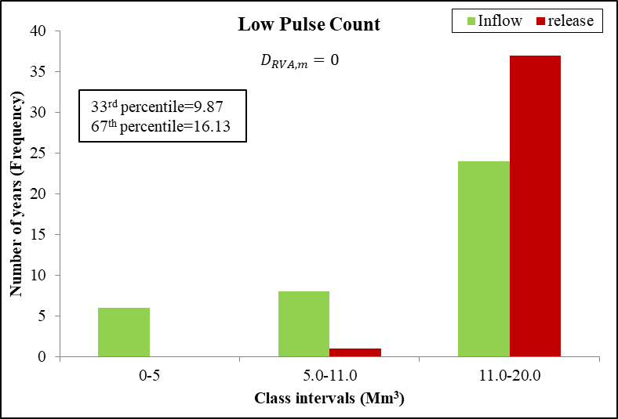 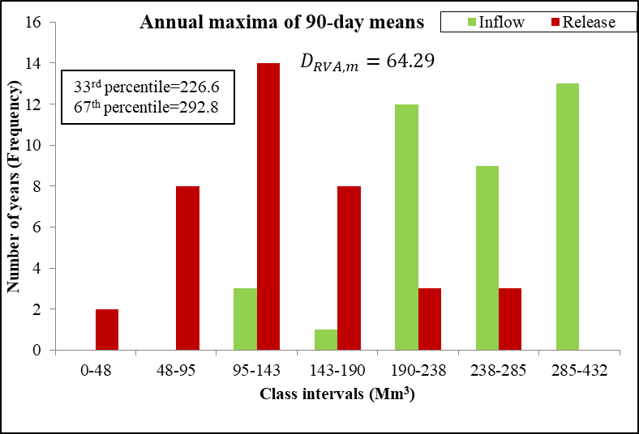

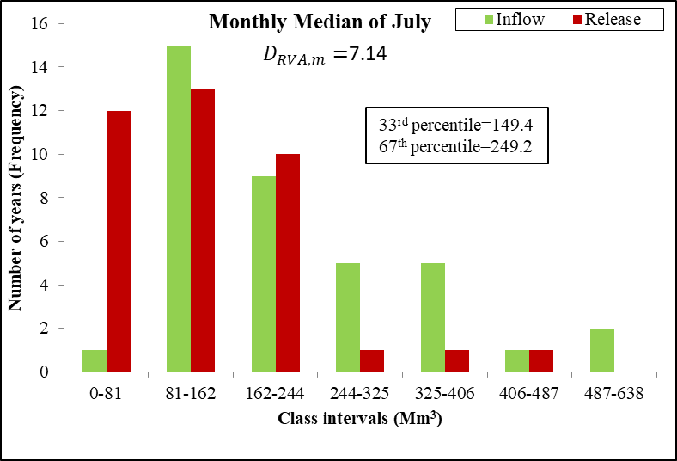 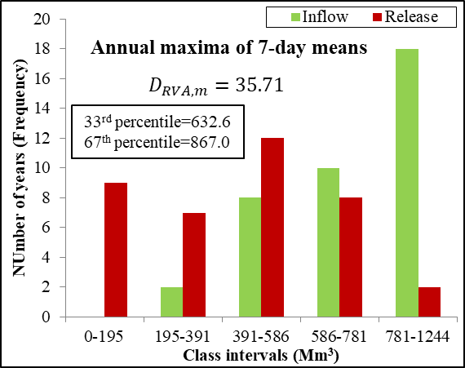

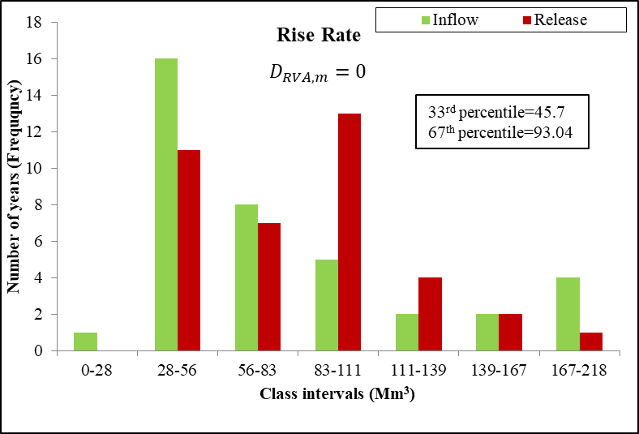 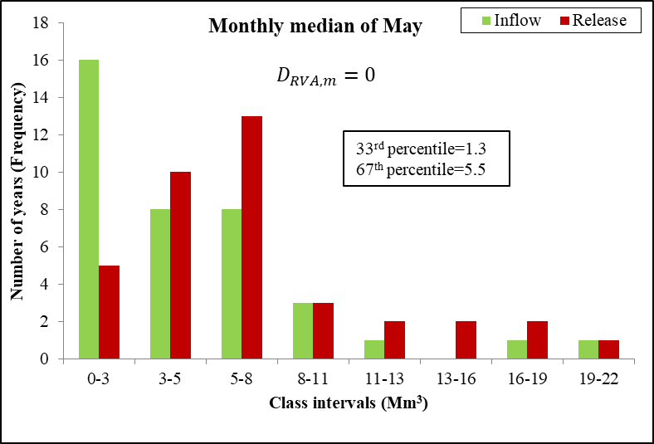

Fig. S4: Distribution of PCA selected release statistics of IMHA-RVA-30.16 across the various class intervals covering the entire range of inflow statistics.

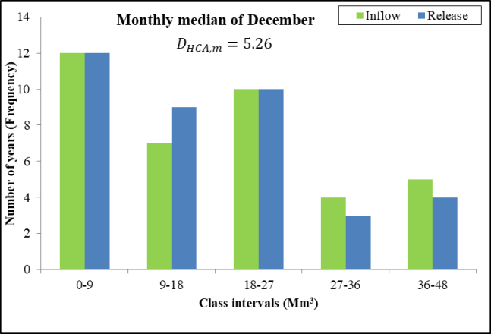 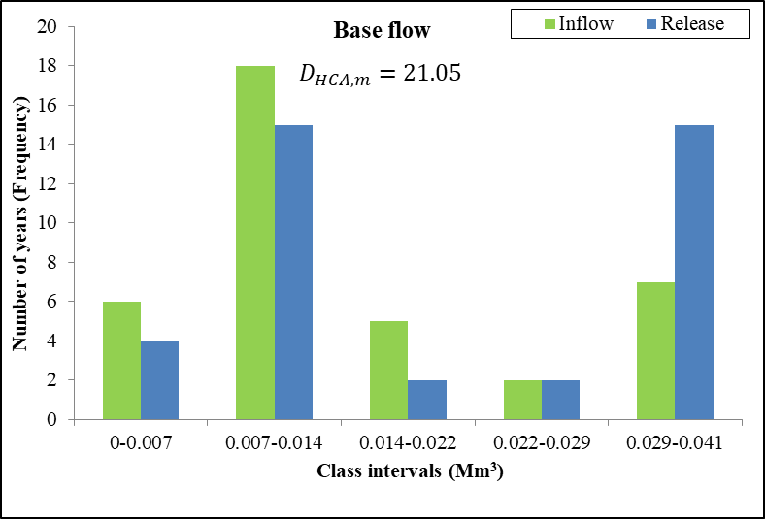

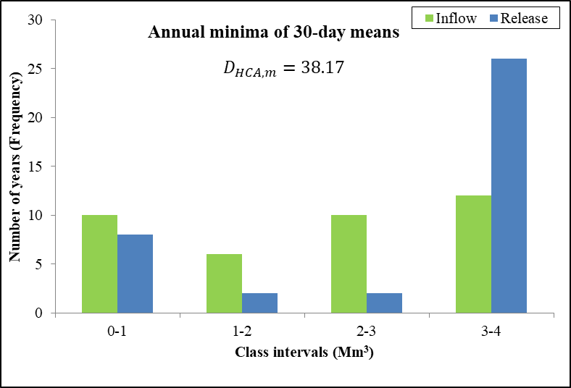 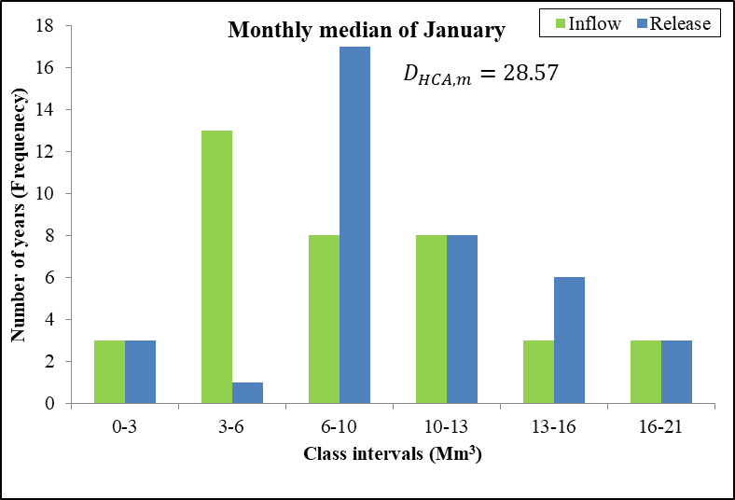

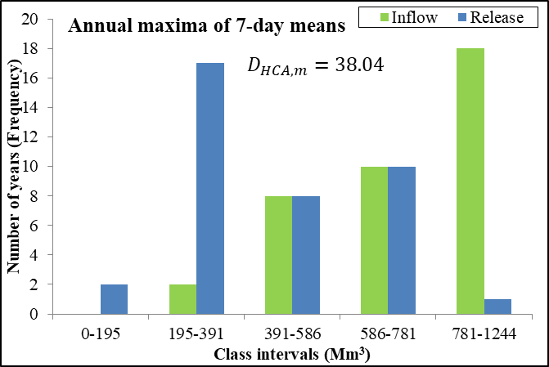

Fig. S5: Distribution of PCA selected release statistics of IMHA-HCA-28.95 across the various class intervals covering the entire range of inflow statistics.